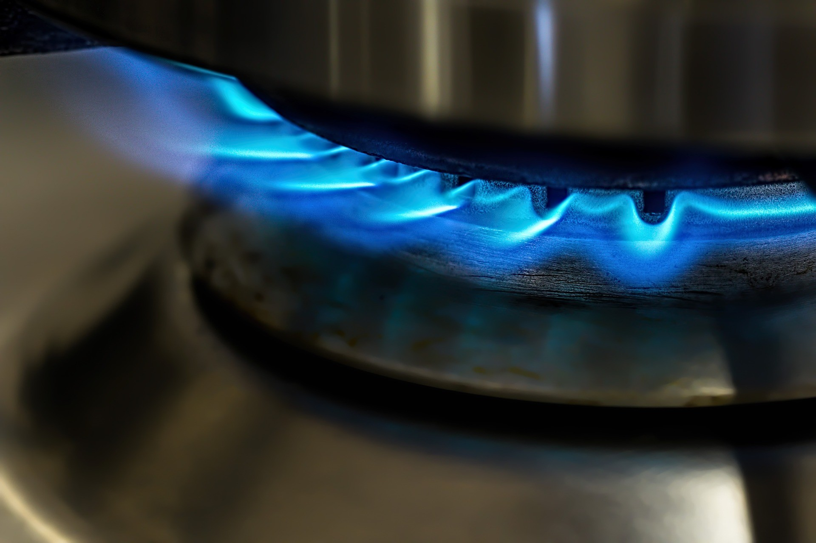

Differentiated
Reading Passages

A Note From The Seller:

I have found that integrating whenever and wherever possible is a great way to make sure that I am addressing all of the Common Core Standards and giving my students enough practice to reach mastery in each skill. With outdated textbooks and lack of resources, I
created close reading passagesand differentiated reading passagesbased on important Social Studies and Science concepts. These passages are designed so that each student in your classroom can access rich content on his or her reading level. Content-specific vocabulary is incorporated into each passage. Each passage is original, research-based, and written in an engaging way to make content come alive. Students enter our classrooms with a wide range of reading levels, yet are expected to master the same content. Each passage comes in THREE LEVELS of differentiation so that you can meet EACH STUDENT at his or her reading level with the SAME rich
content. It is up to you to choose which level you assign each student to use. Remember that Common Core sets RIGOROUS standards for our students and reading levels are higher using Common Core Standards Appendix (Figure 3) as a guideline for these passages. The
following guidelines regarding each passage level will help you determine which passage is best for each student.
The passage included in this set has been analyzed to fit three levels of classroom readers based on the Common Core Standards Reading Levels. The passages are gradually differentiated. Each passage, regardless of the level, contains the same essential information. Easier passages have simpler words and shorter sentences. More challenging passages may have advanced vocabulary and more complex sentences. The questions remain the same for each for ease of grading, whole group grading, and discreet differentiation of student needs.
Note: The passage levels are indicated by DISCREET SHAPES in the corner so that you can tell which level is which without your students ever knowing! The shapes are listed below with the corresponding reading level.

Student is reading BELOW grade level.
Student is reading ON grade level.
Student is reading ABOVE grade level.

Would you like additional differentiated topics for what you arecurrently studying?
Email me at bowtieguy24@gmail.com & I’ll add it to my list of requests!
Check out some more of my differentiated & integrated social studies and science products available in my store!
Acknowledgements& Termsof Use:
Thank you so much for purchasing this product. Please email me at bowtieguy24@gmail.com if you have any questions or would like to request additional topics. I love your feedback! Please visit your “My Purchases” page to leave feedback and earn those credits toward future purchases. Asalways, please respect your fellow teachers and remember thatthis license is for ONE classroom’s use only unless you have purchased additional ones (both print & digital). Please note that the ideas found in this product are intellectual property of me, owner of Bowtie Guy, Inc. You may gladly show samples or pictures of my products, by crediting me and linking back to my TPT store at: www.teacherspayteachers.com/store/bowtieguyandwife
Follow me on https://www.facebook.com/bowtieguy24 Follow me on https://instagram.com/bowtieguyandwife Follow me on
https://www.pinterest.com/bowtieguyandwife
Credit Where Credit Is Due!
Check out these talented designers whose graphics or fonts may have been used in this product.

Copyright Bow Tie Guy 2016

Name:
Conducttion, Convecttion, and Radiattion
Heat moves in many ways. Heat can be moved by conduction. It is moved by convection. It is moved by radiation.
Conduction moves from one solid to another solid. Objects much be touching for
conduction to occur. Heat moves from a burner to the pan. This happens when you turn a stove on to heat up a pan. The heat in the pan then moves to the food you are cooking. The heat from the blanket moves to your body to warm you up when you cover up with an electric blanket. In both situations there is contact between two objects.
Convection is the movement of heat through liquids and gases. The movement creates a current. One example of convection is when you boil water in a pot. The water starts to boil from the bottom and the hot water moves up to the top. Then the cooler water is pushed down. A current of circulating water is formed. Another example is when a space heater is used to heat a room. The air near the heater is heated and circulates the room. This causes the heat to transfer between the hot and cooler air.
Radiation is the transfer of heat energy through waves. Heat energy is given off by the sun’s rays. We can feel the heat energy given off by a campfire. Radiation only travels in waves. It differs from conduction and convection. This is because no contact or current is needed for the heat to transfer. The heat waves from radiation even travels through empty space.

Bo w Tie Guy 2016

Name:

Conducttion, Convecttion, and Radiattion
Heat moves in many ways. Heat can be moved by conduction. It is moved by convection. It is moved by radiation.
Conduction moves from one solid to another solid. Objects much be touching for
conduction to occur. Heat moves from the burner to the pan when you turn a stove on to heat up a pan. The heat in the pan then moves to the food you are cooking. The heat from the blanket moves to your body to warm you up when you cover up with an electric blanket. In both situations there is contact between two objects.
Convection is the movement of heat through liquids and gases. The movement creates a current. One example of convection is when you boil water in a pot. The water starts to boil from the bottom and the hot water moves up to the top. Then the cooler water is pushed down and a current of circulating water is formed. Another example is when a space heater is used to heat a room. The air near the heater is heated and circulates the room, causing the heat to transfer between the hot and cooler air.
Radiation is the transfer of heat energy through waves. Heat energy is given off by the sun’s rays. We can feel the heat energy given off by a campfire. Radiation only travels in waves. It differs from conduction and convection. This is because no contact or current is needed for the heat to transfer. The heat waves from radiation even travels through empty space.

Bo w Tie Guy 2016

Name:

Conducttion, Convecttion, and Radiattion
Heat can be moved in many ways. Heat can be moved by conduction, convection, and by radiation.
Conduction is when the heat from one solid moves to another solid. It’s important to remember that two objects much be touching for conduction to occur. Here are two examples of when conduction takes place: When you turn the stove on to heat up a pan, the heat moves from the burner to the pan. The heat in the pan then moves to the food you are cooking. Also, when you cover up with an electric blanket, the heat from the blanket moves to your body to warm you up. In both situations there is contact between two objects.
Convection is the movement of heat through liquids and gases. The movement creates a current. One example of convection is when you boil water in a pot. The water starts to boil from the bottom and the hot water moves up to the top. Then the cooler water is pushed down and a current of circulating water is formed. Another example is when a space heater is used to heat a room. The air near the heater is heated and circulates the room, causing the heat to transfer between the hot and cooler air.
Radiation is the transfer of heat energy through waves. An example of radiation includes the heat energy given off by the sun’s rays. Due to radiation, we can feel the heat energy given off by a campfire. Radiation only travels in waves and differs from conduction and convection, because no contact or current is needed for the heat to transfer. The heat waves from radiation can even travel through empty space.

Bo w Tie Guy 2016

Conducttion, Convecttion, Radiattion
- How does conduction occur?  - Whatmust happen in order for conduction to take place?  - Describe a situation when conduction occurs.  - Whatis radiation?  - Name two objects that gives off radiation waves.  - How does radiation differ from conduction and convection?  - What is convection?  - Whatdoes the movement create?  - Describe a situation when convection occurs. | Directions: What are some examples of radiation, conduction, and convection? Use the passage to support your answer. Try to think of examples that are not listed in the passage.  _  _  _  _  _  _  _  _  _  _  _  _  _  _  _  _  _  _  _
Directions: In your opinion, what are the five most important | Writing: Compare and contrast conduction, convection, and
facts that should be known the movement of heat energy? List  them below. | radiation as part of heat energy.  _
1. | _  _
 | _
 | _
2. | _  _
 | _
3. | _  _
 | _
 | _
4. | _  _
 | _
5. | _  _
 | _
 | _
Bo w Tie Guy 2016

